**JOIN OUR ACCORDION VISIT TO**

**CASTELFIDARDO – ITALY 2024 flag-italy-XL[1]**

**+ Visit to San Marino**

**Tuesday 01 October – Saturday 05 October**

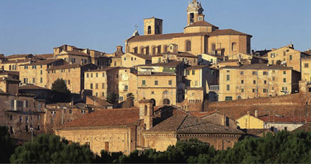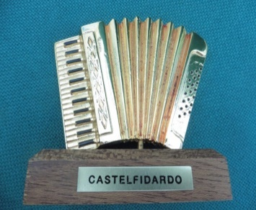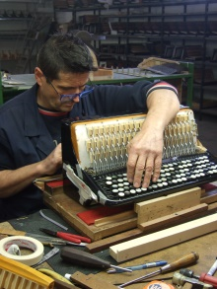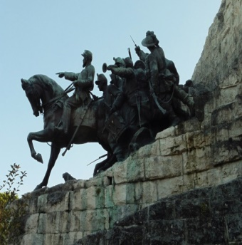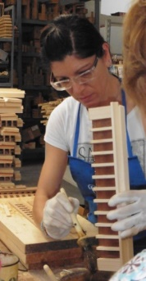

**Dear Accordionists**

In May this year I arranged a return visit to Castelfidardo Italy following the Covid disruption in 2019. We had 40 people on the group from around the UK including some from USA & Canada and it proved an enjoyable 5 days.

I have arranged another visit next year from **1-5** **October** for 5 days. It is possible it could be the last trip of this nature I organise and depends on a number of factors. I am keeping the numbers nearer to 30 people which is more manageable when splitting the group for the visits to the factories..

It is especially an opportunity for those who always wanted to visit ‘Accordion Mecca’ at some point in their life! I know there are a number of people who want to visit Castelfidardo but for one reason or another have not been able to join our group visit so hopefully next year may prove possible for some.

The package **without flights** for 5 days starts at £695pp for twin/double occupancy. Supplement for single use of double room apply. Flights from Heathrow to Bologna in October are currently showing prices of between £100 --£130.

………………………,,,……See overleaf for trip details 

***Summary of the trip…..***

* Fly to Bologna from your nearest airport or to London and join the UK group departure to Bologna on British Airways (book own flights) / Travel by luxury coach from Bologna to Castelfidardo / Coach and driver available with the group throughout the stay / Hotel accommodation for 4 nights with breakfast daily / Hotel is in Numana near the beach and close to Castelfidardo and factories / Visits to factories to see wonderful instruments being built by hand. / Musical demonstrations at the factory showrooms / Play high quality accordions loaned to the group by some of the manufacturers / See also how reeds are produced and how bellows are made / Visit the Carini accordion accessory shop / Visit the Castelfidardo Accordion Museum / Try out the largest working piano accordion in the world / Optional lunchtime visits to some of the attractive nearby towns such as the religious pilgrimage town of Loreto and to see the Basilica and Holy House / Optional visit to Osimo historical underground tunnels / Visit seaside resorts in the evening for dinner and accordion entertainment / Final night private dinner included and a guest accordionist / Group members are able to entertain at the restaurants on the loaned accordions / On the return journey to Bologna there is a stop for around 4 hours in the independent state of San Marino for sightseeing, lunch and shopping.

***Please call for further information and full details.***

Thank you

Peter Le Geyt

**\*UK REPRESENTATIVE FOR PETOSA & GIULIETTI ACCORDIONS**

**\*ACCORDION RELATED SERVICES**

Tel:  + 44 (0)20 8977 6680

Email:  [plg@plgmarketing.com](mailto:plg@plgmarketing.com)